**ABSTRACT**

**Topic: HOME DESIGNS**

It is an online website which includes latest projects and design work done by professionals such as interior designers, architectures, lighting and furnishers. On Demand Home Designs provide verified Professionals to customers on their demands. This site taking away the pain of finding the right home designs expert to fulfill your dream home. With reasonable pricing, customers can avail variety of designs. The user can view the works and can request for their appointment. It includes Home furniture sales and services.

There are mainly three modules:

* 1. Admin
  2. User
  3. Professional
  4. Seller

Admin have the overall control for the website. He can delete fake or unwanted uploads. Registered users can view the professionals and there works and can take appointment. Professional can upload their works and fix appointments. Sellers allows online purchasing of home furnishers.

The user can find the nearest designers and builders for build their dream home.

Domain: Web Technology

Front End : PHP Script

Back End : MySQL

**TABLES**

1. Name : Login

Primary Key: lid

Table Description: Login details of Registered User

|  |  |  |  |
| --- | --- | --- | --- |
| Field | Type | Constraints | Description |
| lid | Int | Primary Key | Login ID |
| Uid | Int | Foreign Key | User ID |
| Pwd | Varchar | Foreign Key | User Password |
| Rid | Int | Primary Key | Role of the User |

1. Name :Role

Primary Key: rid

Table Description:Contains the different roles of users included in the projct

|  |  |  |  |
| --- | --- | --- | --- |
| Field | Type | Constraints | Description |
| rid | Int | Primary Key | Role ID of the User |
| Rname | Varchar |  | Role name of the user |

1. Name : District

Primary Key : did

Table Description : Contains details of district

|  |  |  |  |
| --- | --- | --- | --- |
| Field | Type | Constraints | Description |
| did | Int | Primary Key | District ID |
| dname | varchar |  | District Name |

4) Name :tbl_reg

Primary Key: uid

Table Description: Table stores the registration details

|  |  |  |  |
| --- | --- | --- | --- |
| uid | int | Primary key | User id |
| uname | varchar | Not null | User name |
| uadrs | varchar | Not null | User address |
| umail | email | Not null | User email |
| uphone | int | Not null | Phone number |
| gender | varchar | Not null | Gender |
| did | int | Foreign key | District id |
| rid | int | Foreign key | Rate id |

5)tllcategory

PK: cid

Admin adds different categories here

|  |  |  |  |
| --- | --- | --- | --- |
| Fields | Type | Constraints | Description |
| c_id | int | Primary key | Category id |
| c_name | varchar | Not null | Category name |
| c_type | varchar | Not null | Category type |

6)Offers

PK: o_id

This table stores the offers provided

|  |  |  |  |
| --- | --- | --- | --- |
| **Field** | **Type** | **Constraints** | **Description** |

|  |  |  |  |
| --- | --- | --- | --- |
| **Field** | **Type** | **Constraints** | **Description** |
| **o_id** | int | Primary key | Offer id |
| **image** | varchar | Not null | Offer image |
| **rate** | int | Not null | Offer rate |
| **o_desc** | varchar | Not null | Offer description |

7)Name:Work upload

PK: wid

FK: Cid, uid

Descriptin:Latest projects are added to this table

|  |  |  |  |
| --- | --- | --- | --- |
| **Field** | **Type** | **Constraints** | **Description** |
| **w_id** | int | Primary key | work id |
| **u_id** | int | Foreign key | User id |
| **c_id** | int | Foreign key | Category id |
| **w_desc** | varchar | Not null | Description of work |
| **image** | varchar | Not null | Picture of work |

8)Enquiry table

PK: e_id

Table shows the enquiries and replies

|  |  |  |  |
| --- | --- | --- | --- |
| **Field** | **Type** | **Constraints** | **Description** |
| **e_id** | int | Primary key | Enquiry id |
| **u_id** | int | Not null | User id |
| **enquiry/feedback** | varchar | Not null | Enquiry/feedback |
| **reply** | varchar | Not null | reply |

9)Appointment

PK: a_id

Appointment registration

|  |  |  |  |
| --- | --- | --- | --- |
| **Field** | **Type** | **Constraints** | **Description** |
| **a_id** | int | Primary key | Appointment id |
| **u_id** | int | Foreign key | User id |
| **a_time** | varchar | Not null | Time |
| **desc** | varchar | Not null | description |
| **date** | date | Not null | Date of appointment |
| **status** | varchar | Not null | Status of appointment |

10)Payment

PK: pmt_id

Payment details

|  |  |  |  |
| --- | --- | --- | --- |
| **Field** | **Type** | **Constraints** | **Description** |
| **pmt_id** | int | Primary key | Payment |
| **amount** | varchar | Not null | Amount |
| **card_no** | int | Not null | Card number |
| **date** | date | Not null | Payment date |
| **time** | int | Not null | Payment time |

11)Name : Product Catogory

Primary Key : pid

Table Description : Admin add the product Catogory

|  |  |  |  |
| --- | --- | --- | --- |
| Field | Type | Constraints | Description |
| pid | Int | Primary Key | Product ID |
| pname | varchar |  | Product Name |

12) Name : sproduct

Primary Key: pid

Foreign Key :pid

Table Description: Details of Product

|  |  |  |  |
| --- | --- | --- | --- |
| Field | Type | Constraints | Description |
| pid | Int | Foriegn Key | Product ID |
| Rate | Varchar |  | Product name |
| Desc | Varchar |  | Description |
| Image | Varchar |  | Image of the roduct |
| Selid | Int |  | Seller ID |

13 ) Name : sellprod

Primary Key: spid

|  |  |  |  |
| --- | --- | --- | --- |
| Field | Type | Constraints | Description |
| spid | Int | Primary Key | Sell Product ID |
| selid | int | Foreign Key | Sell ID |
| Pid | Int | Foreign Key | Product id |

14)Name : order

Primary Key :oid

Description : Order description table

|  |  |  |  |
| --- | --- | --- | --- |
| Field | Type | Constraints | Description |
| oid | Int | Primary Key | Order ID |
| Odate | Date |  | Order date |
| uid | Int | Foreign Key | User ID |
| pid | Int | Foreign Key | Product ID |
| Qty | Int |  | quantity |
| amt | Int |  | amount |
| fdate | Date |  | Finishing Date |

15) Name : Payment

Primary Key: pmtid

|  |  |  |  |
| --- | --- | --- | --- |
| Field | Type | Constraints | Description |
| Pmtid | Int | Primary Key | Payment ID |
| oid | Int | Foreign Key | Order ID |
| amt | Int | Foreign Key | User ID |
| cardno | Varchar |  | Card Number |
| Cardtype | Varchar |  | Card Type |

**DFD**

**Level 0**

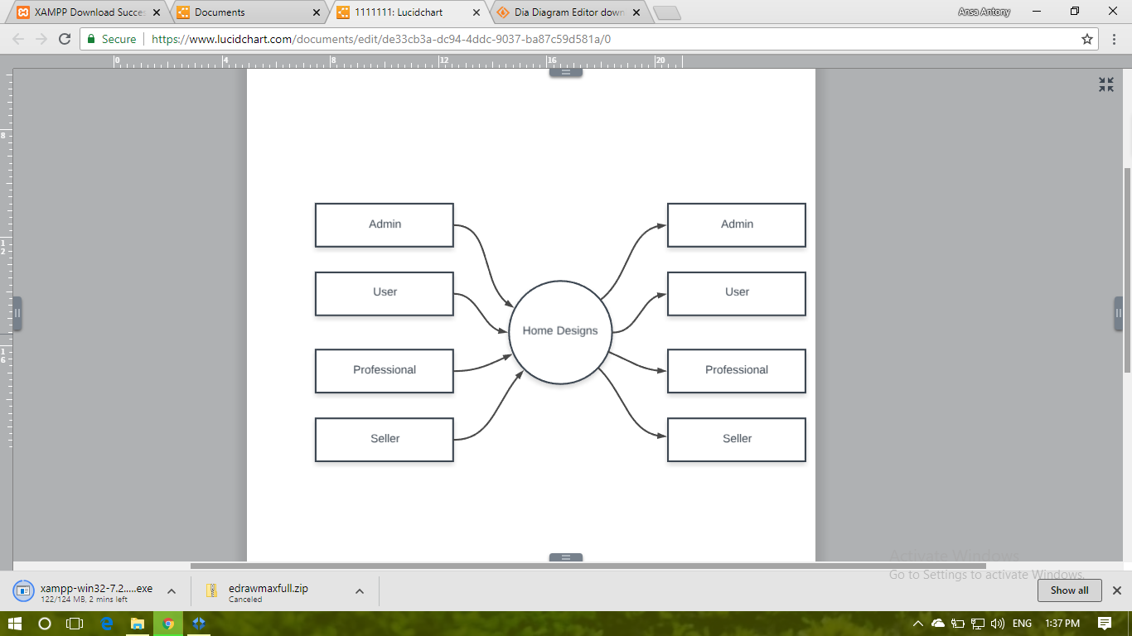

**Level 1: ADMIN**

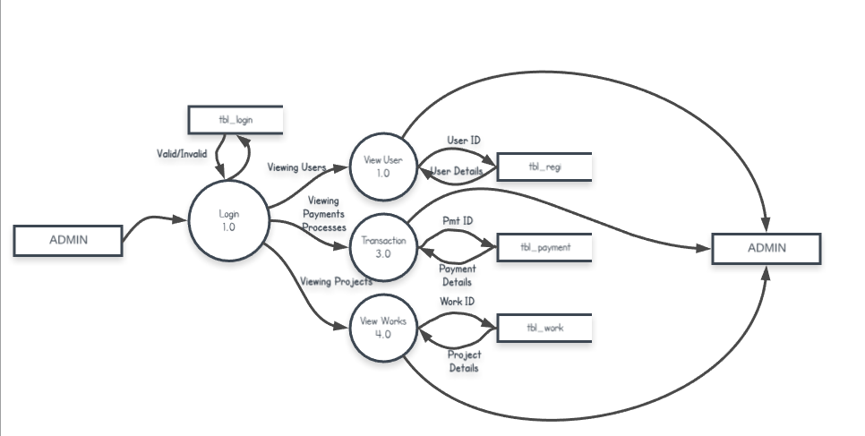

**Level 1: USER**

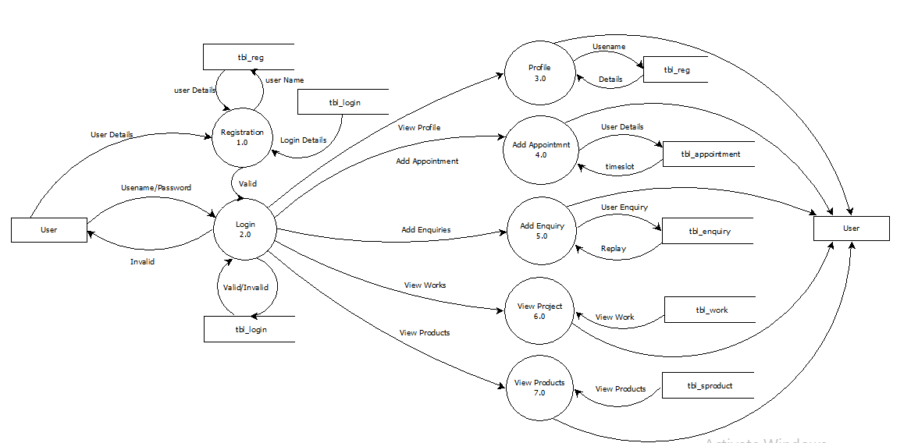

**Level 1: PROFESSIONAL**

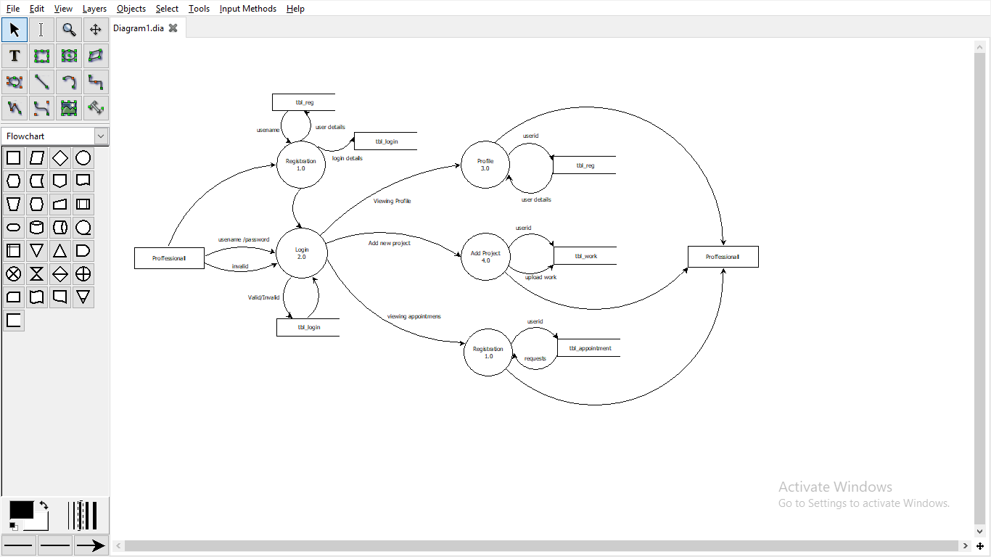

**Level 1: SELLER**

